Special Educational Needs (SEN) information report

Southview School, College and Residential Educational Setting (The View).





Approved by: | Julian Cochrane | Date: 30th June 2026
Last reviewed on: | 30th June 2026
Next review due by: | By 30th June 2027 or sooner if changes occur.
Contents
Introduction 4
What types of SEN does the school provide for? 5
Which staff will support my child, and what training have they had? 5
How will the school measure my child’s progress? 7
How will I be involved in decisions made about my child’s education? 9
How will my child be involved in decisions made about their education? 9
How will the school adapt its teaching for my child? 9
How will the school evaluate whether the support in place is helping my child? 10
10. How will the school resources be secured for my child? 10
How will the school make sure my child is included in activities alongside pupils who don’t have SEN? 10
Admissions process 10
How does the school support pupils with disabilities? 11
How will the school support my child’s mental health, and emotional and social development? 11
What support will be available for my child as they transition between classes or settings, or in preparing for adulthood? 11
What support is in place for looked-after and previously looked-after children with SEN? 12
What should I do if I have a complaint about my child’s SEN support? 12
What support is available for me and my family? 13
Glossary 13

Introduction

Dear parents and carers,
The aim of this information report is to explain how we implement our SEND policy. In other words, we want to show you how special educational needs support works in our school.
If you want to know more about our arrangements for SEND, read our SEND policy.
You can find it on our website https://www.southview.essex.sch.uk/attachments/download.asp?file=520&type=pdf
Please contact our school office if you require a paper copy of the policy.
Note: If there are any terms we’ve used in this information report that you’re unsure of, you can look them up in the Glossary at the end of the report.

What types of SEN does the school provide for?
Southview School is a 3-19 day special school for Physically and Neurologically Impaired (PNI) children and students. Students at Southview School have a range of physical and neurological impairments that significantly impact their ability to access education without specialist support. These may include (but not limited to) physical disabilities such as cerebral palsy, muscular dystrophy, or spina bifida, which can affect mobility, fine and gross motor skills, and independence in daily activities. Students may also have neurological conditions including epilepsy, acquired brain injuries, or neurodevelopmental conditions that affect their learning, communication, sensory processing, and behaviour. Many of our students have complex and multiple needs, requiring personalised support from our multidisciplinary team including teachers, teaching assistants, therapists, and medical professionals. Our provision is designed to remove barriers to learning and enable each student to achieve their full potential, both academically and in developing life skills for greater independence.

Which staff will support my child, and what training have they had?
Specialist Teachers
The school is split into eight classes, each led by a Specialist Teacher. All our Specialist Teachers have responsibility for ensuring student progress is on track for every child in their area, monitoring and evaluating any individual interventions and other leadership roles such as team leadership.
All of our teachers receive in-house SEN training, as well as training provided by external partners such Speech and Language Therapists, Occupational Therapists and Physiotherapists.
Specialist Teaching assistants (TAs)
Each class has a team of Tas that work alongside the Specialist Teachers, or one of our four Higher Level Teaching Assistants (HLTAs) who are trained to deliver provision within our school. Our HLTAs work closely with our Specialist Teachers to ensure a quality, consistent provision for our students.
Intervention Team
From September 2026, we have expanded our Intervention Team, who are trained to provide additional provisions in line with students EHCPs and other identified needs. Our Intervention Team consists of:
Physical Wellbeing Team
- A Lead Specialist Teacher for Physical Wellbeing
- A trained Physiotherapist
- A Medical and Therapy Link Lead
- Seven Physical Wellbeing Assistants
- Two Hydrotherapy Assistants

Communication Team
- A lead teacher for Communication
- Three Communication Assistants

Student Experiences
- A lead teacher for Student Experiences

Wellbeing and Pupil Premium Team
- A Wellbeing Co-ordinator
- A Pupil Premium Co-ordinator

Careers and Post-16 Provision Team
- A Careers and Post-16 Provision lead
- A Careers and Post-16 Provision assistant

Parent Liaison Team
- A Parent Support Worker
- A Parent Liaison

Supportive Learning Team
- An Exams Co-ordinator
- A Distance Learning Co-ordinator

‘The View’ Educational Residential
The View is an additional provision that has been specifically designed to accommodate our student’s needs, making it the perfect place for our students to thrive and enjoy a wonderful residential experience. The View is overseen by our Residential Lead, who is supported by two teams made of a Senior Residential Support worker and three Residential Support Workers.
The main aim of The View is to support individual students with a bespoke package which enables them to develop skills in preparation for their next steps towards becoming a confident and responsible member of our society. We use our Diamond Model of Social Pedagogy to underpin our work.
The View has been designed as an education intervention, to support broad targets and to work with the specific needs and requirements of our unique students. A placement at The View will provide early intervention enabling students to develop individual skills, promote change, build confidence and open up more opportunities for their future. The focus will be around teaching and embedding living and self-care skills, promoting greater independence and self-belief skills as well as preparing students for life beyond Southview. This work will be characterised by a strong partnership, working with the child/student’s family and professionals, who will play a key role in shaping and planning strategies and outcomes.

External agencies and experts
Whenever necessary and beneficial for our students, we will work with external support services to meet their needs and support their families. These can include:
- Speech and language therapists
- Educational psychologists
- Occupational therapists
- GPs or paediatricians
- School nurses
- Child and adolescent mental health services (CAMHS)
- Education welfare officers
- Social services and other local authority (LA)-provided support services
- Voluntary sector organisations

How will the school measure my child’s progress?
Southview assesses the holistic education of all it’s students. As such, student’s progress is measured against targets set in the following areas:
Cognition and Learning
Personal, Social and Emotional
Independence and Self Help
Communication
Physical
The View (if they attend)

If a student attends sessions with our Intervention Team, they will also measure termly progress on our assessment platform.
Progress will be measured as:
- Needs Attention
- Some Progress
- Expected Progress
- Strong Progress
There is no standardised measure of progress for our students, and progress will be judged by our Specialist Teachers against the progress they believe each student should be making.
We will follow a graduated approach to meeting your child’s SEN needs, which is a four part cycle shown below.

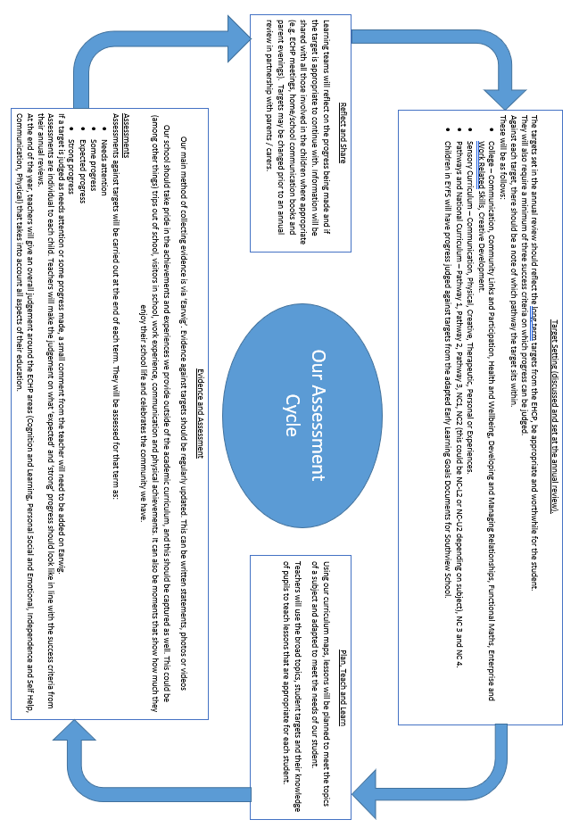

How will I be involved in decisions made about my child’s education?
All parents / guardians will be invited to relevant meetings such as the Annual Review of an ECHP in which targets are discussed and may be changed. We welcome parental input alongside the views of our Specialist Teachers, Intervention Team and outside agencies to produce the best possible outcomes for students. During annual review meetings, parents are invited to be involved in the discussion around ECHP changes, targets, aspirations and other provisions available within the school or fron outside support.
During the school year, we provide an annual report on our student’s progress towards the end of the academic year. We also have two parent consultation weeks per year where parents can book an appointment to discuss progress with their specialist teacher.
After any discussion we will make a record of any outcomes, actions and support that have been agreed. This record will be shared with all relevant staff, and you will be given a copy.
If you have concerns that arise between these meetings, please contact your child’s class teacher. Each student has a home school communication book or an online messaging service through Class Dojo in which concerns can be raise. Teachers will inform parents or guardians at the beginning of the school year which method is used within the class.

How will my child be involved in decisions made about their education?
The level of involvement will depend on your child’s age and their level of communication and understanding. We recognise that no two children are the same, so we will decide on a case-by-case basis, with your input.
We may seek your child’s views by asking them to:
- Attend meetings to discuss their progress and outcomes
- Prepare a presentation, written statement, video, drawing, etc.
- Discuss their views with a member of staff who can act as a representative during the meeting
- Complete a survey

How will the school adapt its teaching for my child?
Our Specialist Teachers are responsible and accountable for the progress and development of all pupils in their class. We are confident in our specialist teacher's ability to provide high-quality education as our first step in responding to your child’s needs. We will make sure that your child has access to a broad and balanced curriculum in every year they are at our school.
Each term has an overarching topic and skills from the national curriculum that are adapted to be age appropriate, meet the needs of individual learners and allow students to access a range of topics throughout their school journey.
In addition to readily available support such as AAC devices, adaptations can include:
- Adapting our teaching, for example, giving longer processing times, pre-teaching of key vocabulary, reading instructions aloud, and ensuring communication is correct for the pupil etc.
- Adapting our resources and work expectations for allow for high aspirations and success.
- Using technology to support learning such as laptops, iPad or specialist software.
- Supporting students one a 1:1 or small group basis.
In addition to quality first teaching and universal resources, specialist teachers will also use support given by external partners such as Speech and Language Therapists to support learning and allow students to achieve their goals.

How will the school evaluate whether the support in place is helping my child?
We will evaluate the effectiveness of provision for your child by:
- Reviewing their progress towards their goals each term which is also moderated by our Senior Leadership team, and Curriculum and Assessment Lead.
- Reviewing the impact of interventions each term
- Holding an annual review

10. How will the school resources be secured for my child?
In line with our funding arrangement, it may be that your child’s needs mean we need to secure:
- Extra equipment or facilities
- More teaching assistant hours
- Further training for our staff
- External specialist expertise
If that’s the case, we will consult with external agencies to get recommendations on what will best help your child access their learning.

How will the school make sure my child is included in activities alongside pupils who don’t have SEN?
All of our activities within school, visits outside of school and our educational residential setting are carefully designed to allow regular opportunities for all students to partake.
All pupils are encouraged to attend at least one experience planned by our Student Experience Lead as well as trips planned by the class Specialist Teacher. Additionally, special events such as Sports Day, Pantomimes and external visitors are adapted to allow all students to access.
No pupil is ever excluded from taking part in these activities because of their SEN or disability and we will make whatever reasonable adjustments are needed to make sure they can be included.

Admissions process
Placement of a pupil at the school is the decision of the LA in consultation with the school and parents. Students will be considered for the school when it is clear that they will benefit from the provision and that they meet the following criteria:
- The pupil has a statement or Education Health Care plan.
- The pupil’s prime need is identified as severe physical difficulty combined with a neurological impairment.
- The pupil may have additional needs, which could include:
- Speech and language difficulties
- Medical needs
- Learning difficulties

It is the Local Authority who have responsibility for admissions to the School.
If you would like more information please see the link below:
School places for children with SEND - Essex County Council
Alternatively, if you would like to speak with someone at the Local Authority about SEND places in schools, you can use the details below
Statutory Assessment Service
Causeway House
Bocking End
Braintree
Essex
CM7 9HB
Local Authority: 03330134736

How does the school support pupils with disabilities?
As a purpose-built special school for pupils and students aged 3-19 with physical and neurological impairment and associated learning difficulties, all pupils have access, where appropriate, to all areas of the school building and premises.
The school has a car park with disabled bays to the front of the building, and open access by means of a sliding door into the school building. The school is on one level, with no stairs. Corridors are wide enough to allow for students to manoeuvre with wheelchairs and walking aids such as frames. Reception is accessible and there is a waiting area at the front of the building large enough to accommodate wheelchairs.
All classroom doors with the exception of Sunshine class (school nursery), are accessible for children and students by means of a push button entry system which allows them independent access and free movement around the school building. All toilets and hygiene areas are wheelchair accessible, and have mobile and overhead hoists plus changing beds for pupils with more complex physical disabilities.
Every pupil has a risk assessment carried out and a care plan drawn up by qualified assessors to enable pupils to be moved and supported safely for personal, educational and hygiene purposes. The school also has a range of resources including adapted furniture and equipment. Interactive whiteboards and both low and high tech communication aids are used throughout the school to enable all pupils to have full access to the curriculum. All classroom areas have access to an outside area enabling easy escape during an emergency.

How will the school support my child’s mental health, and emotional and social development?
We provide support for pupils to progress in their emotional and social development in the following ways:
- Regular check in by class staff, particularly by staff trusted by the student
- Additional activities aimed to improve mental health, emotional and social development such as social clubs, school councils and out Southview Seal of Approval Scheme.
- We also have a wellbeing coordinator available to take students on a 1:1 basis or small group to support mental health, emotional and social development.

What support will be available for my child as they transition between classes or settings, or in preparing for adulthood?
Change of teacher
To help pupils with SEN be prepared for a change of teacher we:
- Facilitate meetings between the current teacher and previous teacher
- Organise opportunities for students to meet their new teacher
- Inform home of upcoming changes
- Where needed, organise additional resources such as social stories.
Between schools
When your child is moving on from our school, we will ask you and (where appropriate) your child what information you want us to share with the new setting.
Between sites
Southview is based over two sites. Throughout their time, students will attend activities such on each site to prepare them for the move between the lower and upper site. Children will usually move between sites in year 6 or 7, depending on what the school deems best for the student.
Between sites
We work with the pupil to help them achieve their ambitions, which can include goals in higher education, employment, independent living and participation in society. Our dedicated Careers Team works alongside the Upper Site Specialist Teachers to achieve students aims.

What support is in place for looked-after and previously looked-after children with SEN?
Carol Park (Deputy Head Teacher) and Shane Edwards (Senior Assistant Head Teacher) will work alongside our Specialist Teachers to ensure they understand how a looked-after or previously looked-after pupil’s circumstances and their SEN might interact, and what the implications are for teaching and learning.
Children who are looked-after or previously looked-after will be supported much in the same way as any other child who has SEN. However, looked-after pupils will also have a personal education plan (PEP). We will make sure that the PEP and any SEN support plans or EHC plans are consistent and complement one another.

What should I do if I have a complaint about my child’s SEN support?
Our school’s complaint procedure can be found at https://www.southview.essex.sch.uk/attachments/download.asp?file=578&type=pdf
Complaints about SEN provision in our school should be made to the class teacher, or a member of the Senior Leadership Team in the first instance. They will then be referred to the school’s complaints policy.
If you are not satisfied with the school’s response, you can escalate the complaint. In some circumstances, this right also applies to the pupil themselves.
To see a full explanation of suitable avenues for complaint, see pages 246 and 247 of the SEND Code of Practice.
If you feel that our school has discriminated against your child because of their SEN, you have the right to make a discrimination claim to the first-tier SEND tribunal. To find out how to make such a claim, you should visit: https://www.gov.uk/complain-about-school/disability-discrimination
You can make a claim about alleged discrimination regarding:
- Admission
- Exclusion
- Provision of education and associated services
- Making reasonable adjustments, including the provision of auxiliary aids and services
Before going to a SEND tribunal, you can go through processes called disagreement resolution or mediation, where you try to resolve your disagreement before it reaches the tribunal.

What support is available for me and my family?
If you have questions about SEN, or are struggling to cope, please get in touch with out Parent Support Worker and Parent Liaison who can offer support to you, your child, and family.
To see what support is available to you locally, have a look at Essex’s local offer. Essex publishes information about the local offer on their website:
https://www.essex.gov.uk/children-young-people-and-families/find-support-services-children-and-their-families/send-local
Our local special educational needs and disabilities information, advice and support (SENDIAS) services are:
https://www.essexsendiass.co.uk/
National charities that offer information and support to families of children with SEN are:
- IPSEA
- SEND family support
- NSPCC
- Family Action
- Special Needs Jungle

Glossary
- Access arrangements – special arrangements to allow pupils with SEN to access assessments or exams
- Annual review – an annual meeting to review the provision in a pupil’s EHC plan
- Area of need – the 4 areas of need describe different types of needs a pupil with SEN can have. The 4 areas are communication and interaction; cognition and learning; physical and/or sensory; and social, emotional and mental health needs
- CAMHS – child and adolescent mental health services
- Differentiation – when teachers adapt how they teach in response to a pupil’s needs
- EHC needs assessment – the needs assessment is the first step on the way to securing an EHC plan. The local authority will do an assessment to decide whether a child needs an EHC plan
- EHC plan – an education, health and care (EHC) plan is a legally-binding document that sets out a child’s needs and the provision that will be put in place to meet their needs
- First-tier tribunal / SEND tribunal – a court where you can appeal against the local authority’s decisions about EHC needs assessments or plans and against discrimination by a school or local authority due to SEN
- Graduated approach – an approach to providing SEN support in which the school provides support in successive cycles of assessing the pupil’s needs, planning the provision, implementing the plan, and reviewing the impact of the action on the pupil
- Intervention – a short-term, targeted approach to teaching a pupil with a specific outcome in mind
- Local offer – information provided by the local authority that explains what services and support are on offer for pupils with SEN in the local area
- Outcome – target for improvement for pupils with SEN. These targets don't necessarily have to be related to academic attainment
- Reasonable adjustments – changes that the school must make to remove or reduce any disadvantages caused by a child’s disability
- SENCO – the special educational needs co-ordinator
- SEN – special educational needs
- SEND – special educational needs and disabilities
- SEND Code of Practice – the statutory guidance that schools must follow to support children with SEND
- SEN information report – a report that schools must publish on their website, that explains how the school supports pupils with SEN
- SEN support – special educational provision that meets the needs of pupils with SEN
- Transition – when a pupil moves between years, phases, schools or institutions or life stages

