**Southview School**

**Lockdown Newsletter**

**Part 2**

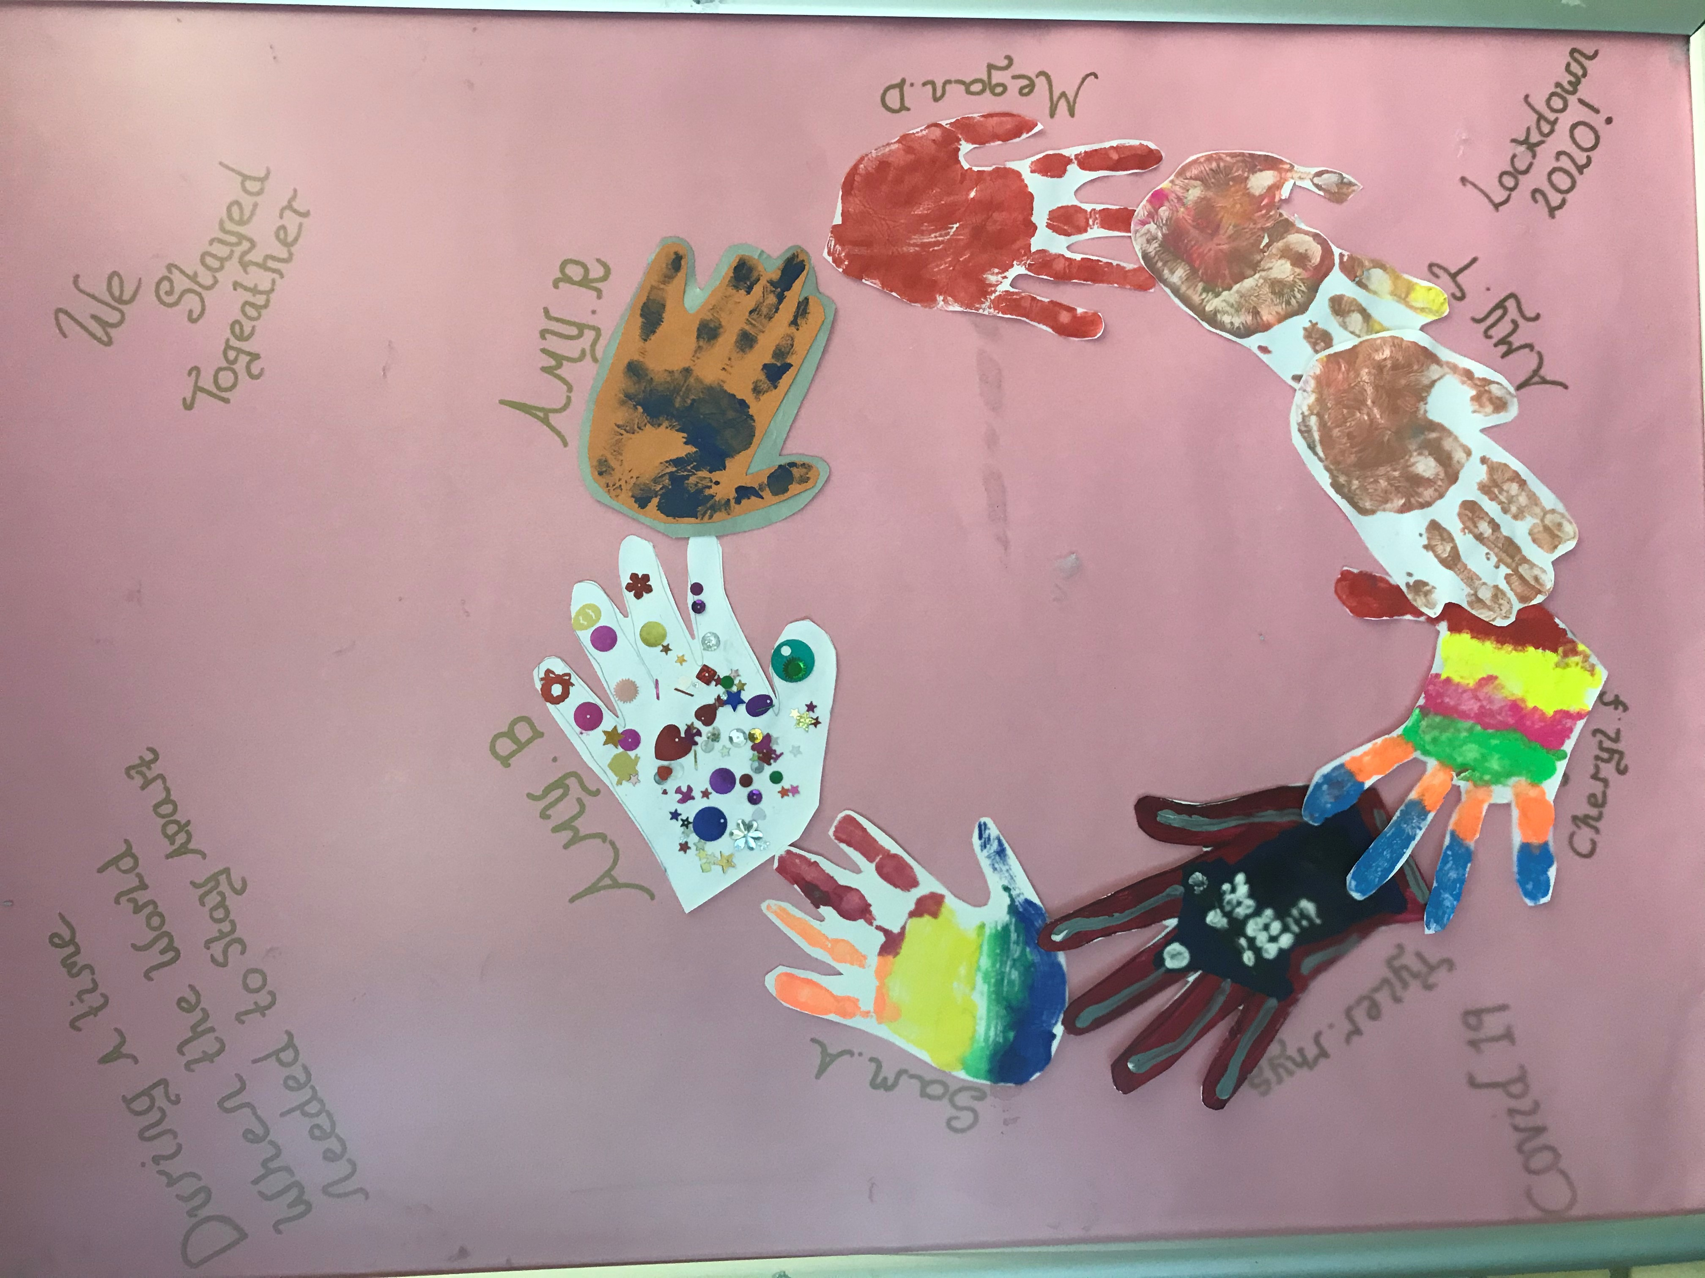

**We have made hand print art of the children who are still attending school – we would love to have handprint art sent in from home (a photo is fine) and we will make another ‘together from home’ piece of artwork.**

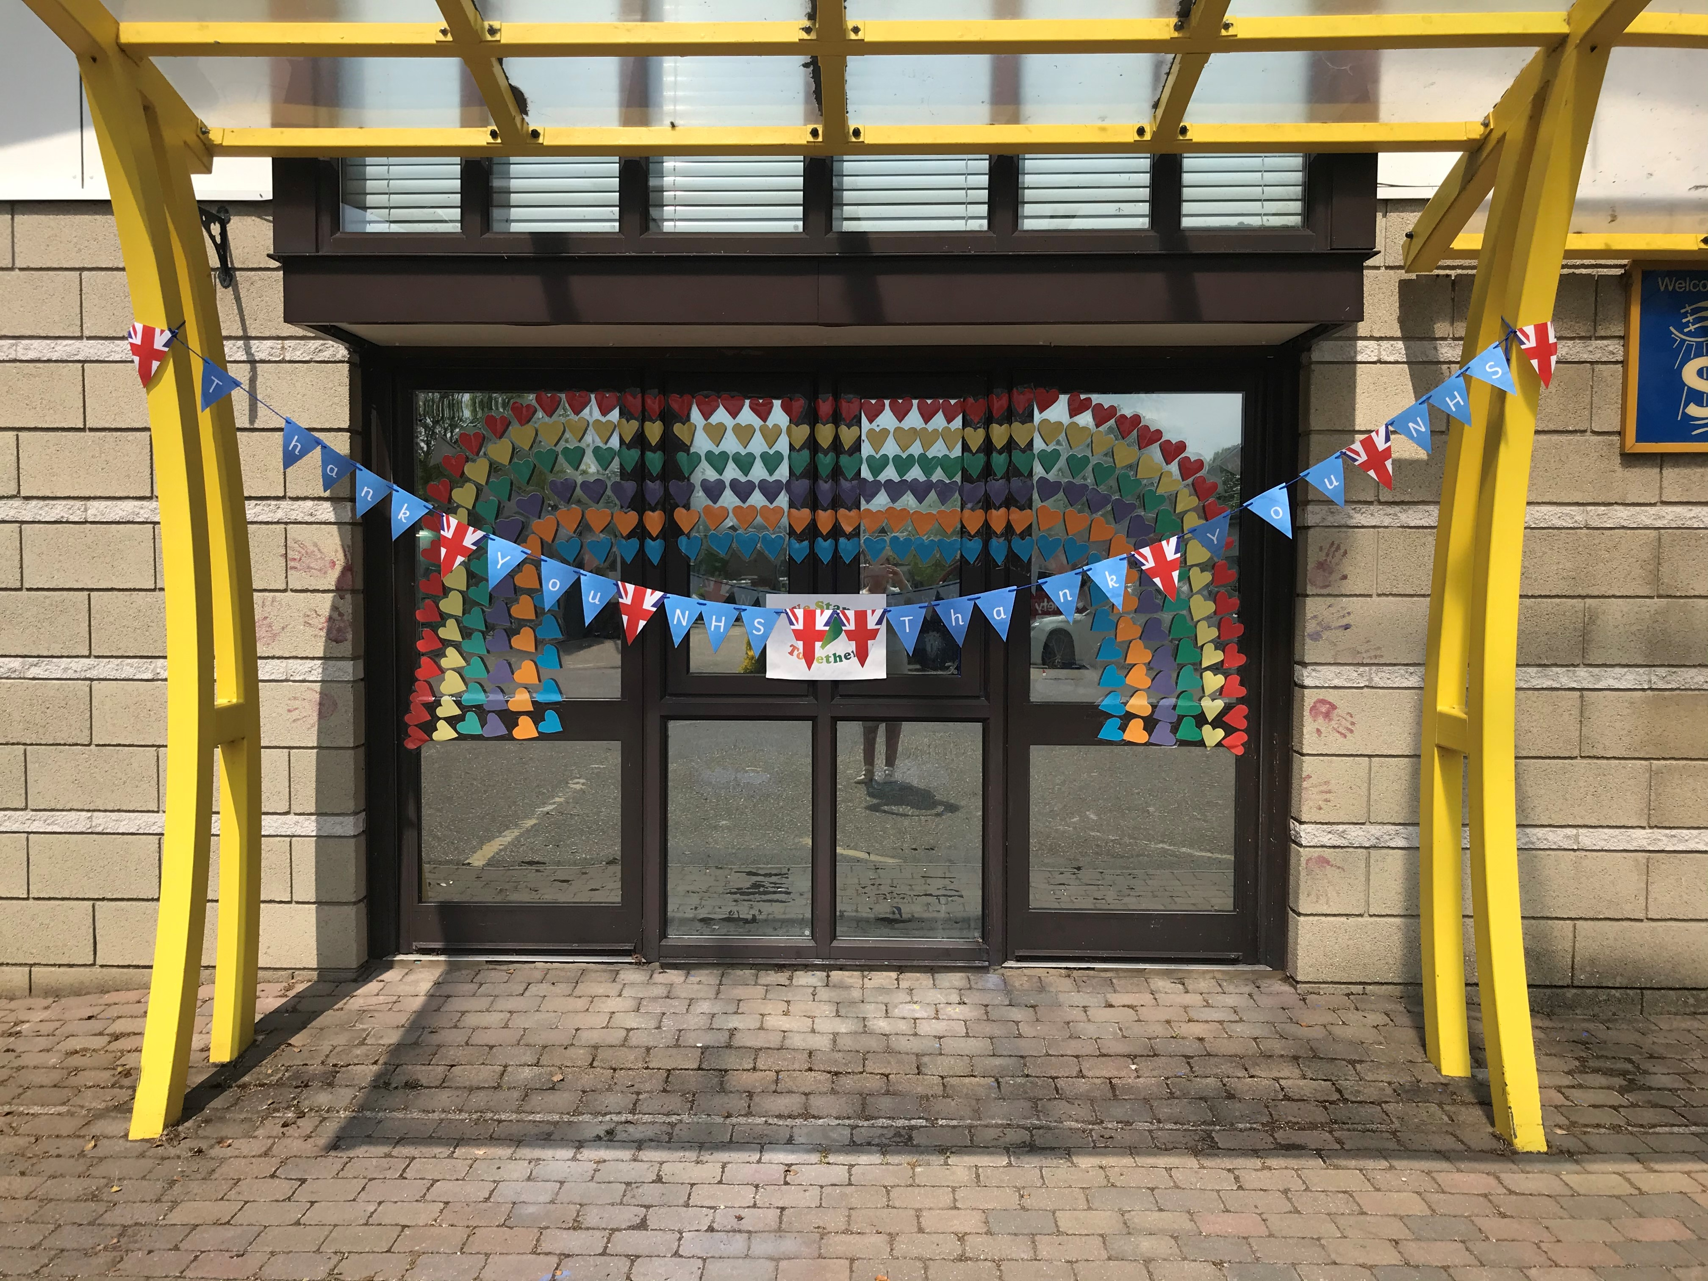

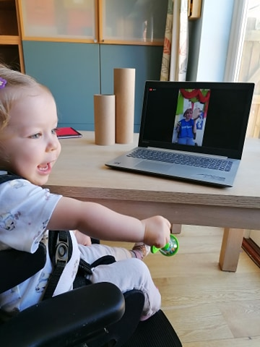

**Dr Ollie Smith has been busy making sure his toys are all safe and well! How clever Ollie!**

**Ollie has also been painting some pebbles – these are so lovely – well done!**

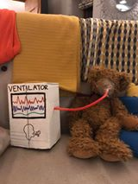

**Our little superstar Elsie who attends School for Parents, had a brilliant music session with Liz and as you can see she is all smiles!**

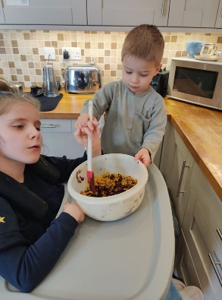

**Evie and her little brother Max have been cooking up a storm!**

**Hope mine is in the post!**

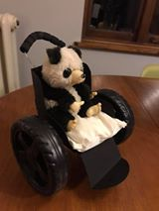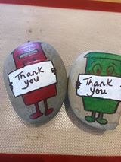

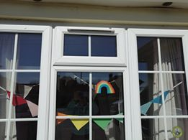

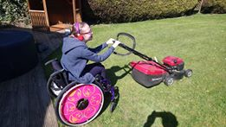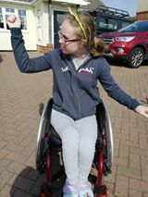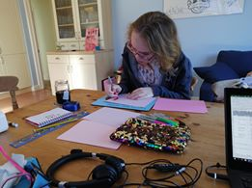

**Jess G has been non-stop! Mowing the lawn, BBC Essex Dance on your doorstep every week, and some college work. Jess also decorated her bedroom window and I think we all agree it looks great!**

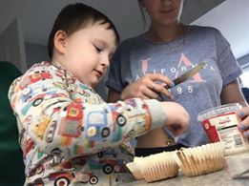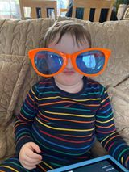

**Tommy has been making yummy cakes with his sister… well when he hasn’t been practising his pout that is! Love the glasses Tommy!**

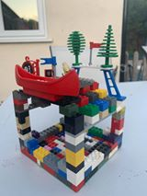

**Dom has been so clever and made a bird house completely out of Lego! What an amazing idea!**

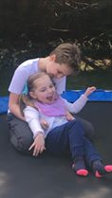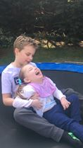

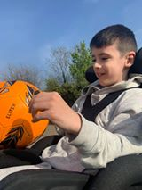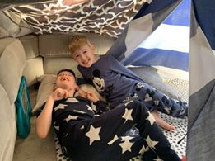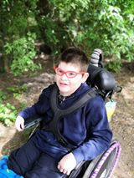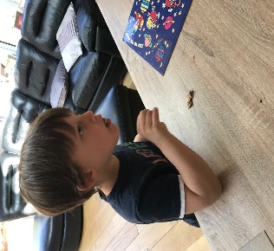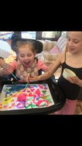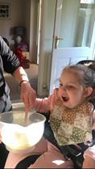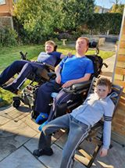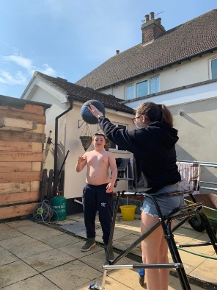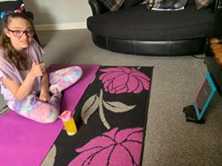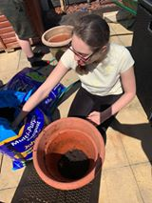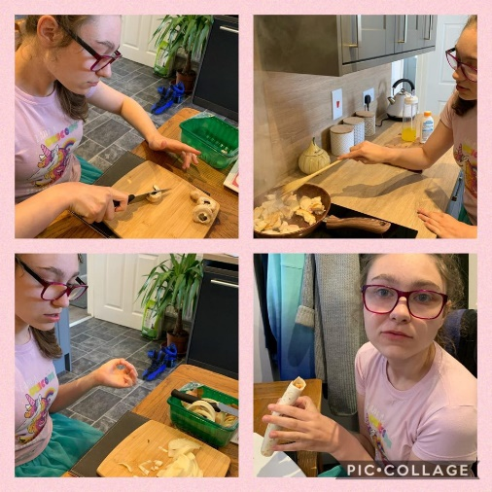

Alfie has been out and about feeding the ducks… well done Alf!

**Riley has been having a ball! Loving that cheeky smile Riley!**

**Jack has been doing so well feeding himself – well done Jack!**

**Rosie has been having lots and lots of fun – look at the smile!**

**Painting and cooking as well as garden fun….. Rosie you have been a busy girl!**

**Here is a picture of Matthew in the garden with his brothers! Keep enjoying the sunshine lads!**

**Jamie-Lee has been very busy! Baking, yoga, gardening and basketball! You’re putting me to shame Jamie-Lee!**