**Southview School**

**Lockdown Newsletter**

**Part 1**

**Well what a start to the Summer Term! It definitely isn’t what we had planned but we hope that everyone is staying safe!**

**Please know that Southview are here for you all. If you need any help, support, advice or activities please contact us and we will get something sorted.**

**Here are some of our students showing what they have been up to over the last few weeks – what an amazing bunch of young people we have at this school!**

**Please send over your photos, stories, pictures or questions to zoec@southview.essex.sch.uk**

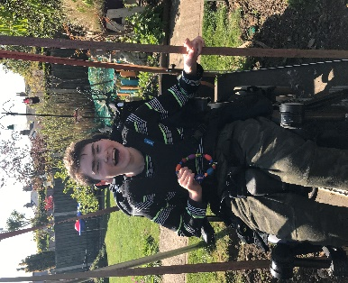

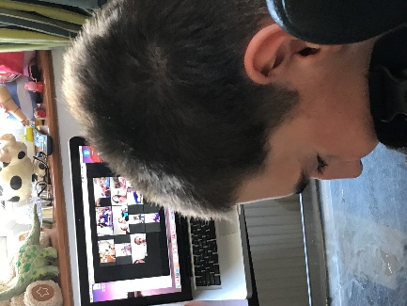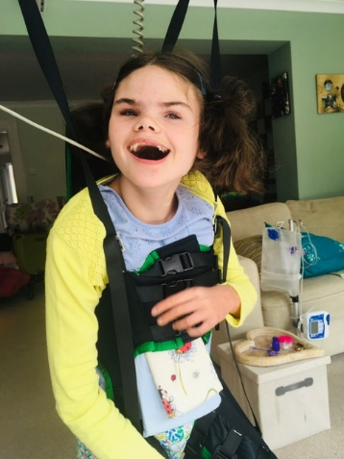

**A huge WELL DONE to Ava who has been a very busy bunny! Not only has she been named Diddi Dancer of the week for her wheelchair dancing, she has also raised £1,000.00 and counting for SNAP by doing a physiotherapy based 2.6 challenge!**

**We are all very proud of you Ava!**

**As you can see Joey has been having lots of fun! Hot tubs, Zoom music sessions, friction balloon fun and even time on the swing…. well done Joey!**



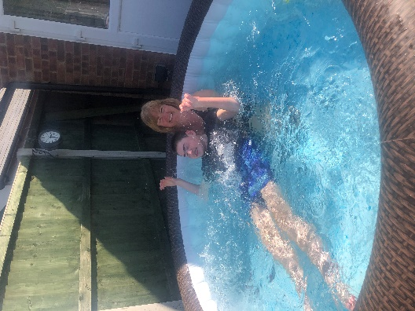



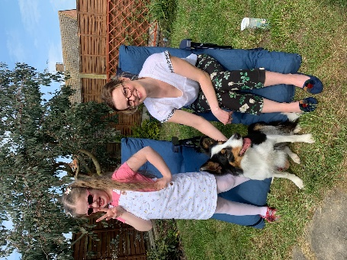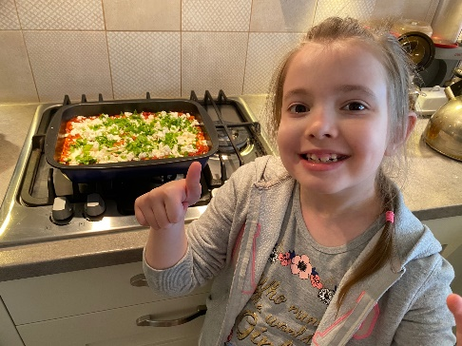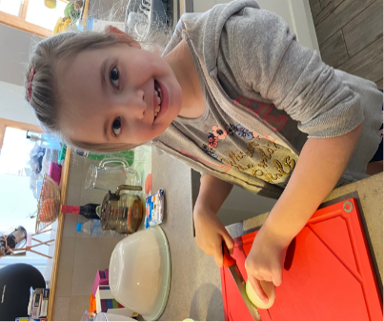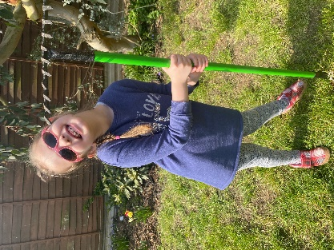

**Maja has been a very busy little lady! Lots of gardening in the sunshine and cooking mummy and daddy dinner! Well done Maja!**

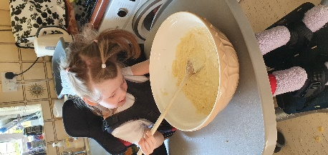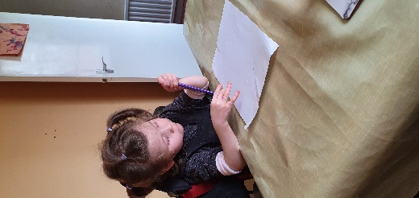

**Isobel has been having lots of fun with her sister! You must be all worn out Isobel, I hope you saved me a cake!**

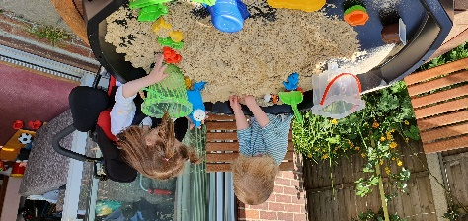

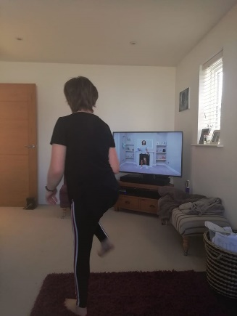

**Jess has been non-stop by the looks of it! Joe Wicks every day (Ashamed to say I lasted one morning!), Pebble painting and a group tent sleepover! Phew – I need a lie down after all that Jess!**

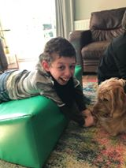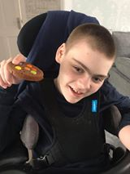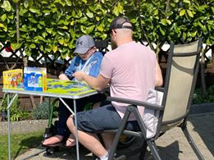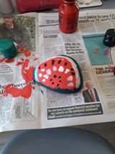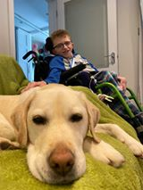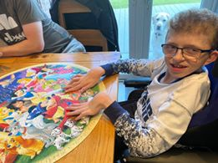

**I’m sure you will all agree that Noah has the cheekiest grin around! He certainly looks like he is having so much fun! Noah has been an absolute superstar in his walker!**

**Bailey has been having a yummy cookie treat every week, no wonder he has such a big smile on his face! I think mine has just been lost in the post hasn’t it Bailey!**

**Lovely to see our smiley Ted doing so well! He has also been a busy boy… movies with the very cute Betty the dog, puzzles and even games in the sunshine! Well done Ted!**